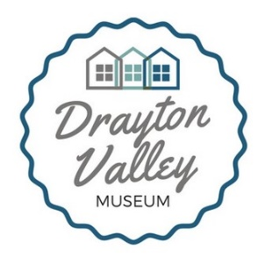
Drayton Valley Museum
Box 5099, Drayton Valley, AB T7A 1R3
(780) 542-5482 dvmuseum@gmail.com

Job Title: Collections Assistant
Start date: May 13, 2019
End date: August 23, 2019
Salary: $17.50/hr
Positions available: 1
Location of work: Drayton Valley Museum, 5009 Weycan Drive, Drayton Valley, AB T7A-1R3
Hours: 37.5hrs/wk, schedule to be set upon arrival)
Position Details:
The Collections Assistant will be responsible for directly assisting the Collections Technician to undertake collections projects including: conducting a collections audit, researching objects in the collection and gathering provenance, completing a risk assessment of the collection, researching and generating a report on best closing practices for the collections department, and developing innovative storage solutions for the Museum’s collections. The Collections Assistant will also act as a summer interpreter to provide tours and visitor services to guests of the Museum.
Candidate Requirements:
Education: the candidate must be enrolled with a secondary or post-secondary institution and intending to continue their education in the fall of 2019. Candidates considering enrolling in, or are enrolled in, a post-secondary program in Heritage Management/Museum Studies, or in an equivalent Fine Arts, History, Anthropology, Archaeology or Education program will be given preference, though related disciplines will be considered. Ideally, the candidate should be planning to pursue a career in a culture and/or heritage field.
Experience: candidates who have a combination of education and experience working in a museum/non-profit environment will be given preference.
Skills:
Computer: proficiency with Microsoft Word and Microsoft Excel; proficiency with various social media platforms will be considered an asset; experience with PastPerfect museum software is not required, but preferred; excellent verbal and written communication skills, attention to detail, flexibility, proactive thinking, ability to work cooperatively and individually, and willingness to learn and be challenged.

Application Process:
Please submit your resume and cover letter to:
Drayton Valley Museum
dvmuseum@gmail.com
OR
Upload your resume and cover letter to the online application form, available at https://www.draytonvalleymuseum.com/employment-opportunities
Application deadline: May 8th, 2019
Please not that the position is funded by the Town of Drayton Valley, Brazeau County, and Government of Canada’s Canada Summer Jobs grant. Positions are subject to the criteria of the Canada Summer Jobs program:
- Candidates must be between the ages of 15 to 30;
- Candidates must be full-time students intending to return to their studies in the next term.
Successful applicants will be contacted for interviews before May 10th, 2019.

