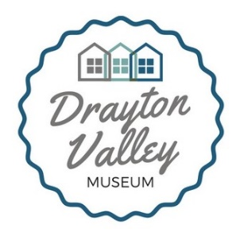
Drayton Valley Museum
Box 5099, Drayton Valley, AB T7A 1R3
(780) 542-5482 dvmuseum@gmail.com

Job Title: Programs Lead
Start date: May 13, 2019
End date: August 23, 2019
Salary: $18.50/hr
Positions available: 1
Location of work: Drayton Valley Museum, 5009 Weycan Drive, Drayton Valley, AB T7A-1R3
Hours: 37.5hrs/wk, schedule to be set upon arrival)
Position Details:
The Programs Lead will be responsible for overseeing all summer programs at the Museum, developing new, engaging, and innovative programs, creating a programs schedule for 2020, updating permanent exhibits in two of the Museum’s historic buildings, interviewing residents from Drayton Valley and Brazeau County to gather their histories about the area, and managing additional programming staff and volunteers. The Programs Lead will be responsible for delivering summer programs, marketing the Museum’s operations to the public, and writing detailed program descriptions for future staff and volunteers efforts.
Candidate Requirements:
Education: the candidate must be enrolled with a post-secondary institution, preferably in a Heritage Management/Museum Studies program, or in an equivalent Fine Arts, History, Anthropology or Education program, although related disciplines would be considered. Ideally, the candidate should be planning to pursue a career in a culture and/or heritage field.
Experience: candidates who have a combination of education and experience working in a museum/non-profit environment will be given preference.
Skills:
Computer: proficiency with Microsoft Word and Microsoft Excel and Google Suite applications is required; proficiency with various social media platforms will be considered an asset (knowledge of using the Wix.com website builder will be considered a strength for applicants); experience with PastPerfect museum software is not required, but preferred; excellent verbal and written communication skills, attention to detail, flexibility, proactive thinking, ability to work cooperatively and individually, and willingness to learn and be challenged.
Application Process:
Please submit your resume and cover letter to:
Drayton Valley Museum
dvmuseum@gmail.com
OR
Upload your resume and cover letter to the online application form, available at https://www.draytonvalleymuseum.com/employment-opportunities
Application deadline: May 8th, 2019
Please not that the position is funded by the Town of Drayton Valley, Brazeau County, and Government of Canada’s Canada Summer Jobs grant. Positions are subject to the criteria of the Canada Summer Jobs program:
- Candidates must be between the ages of 15 to 30;
- Candidates must be full-time students intending to return to their studies in the next term.
Successful applicants will be contacted for interviews before May 10th, 2019.

